Testing Report for Elevator Control System

Contents
1. Introduction 3
2. Testing Objectives 3
3. Test Environment 3
4. Test Design and Methodology 4
5. Test Scenarios and Results 4
5.1 Task 1 - GUI Functionality 4
5.2 Task 2 - Control Logic 4
5.3 Task 3: Data management and logging 5.3. 5
5.4 Task 4 - Animation 5
5.5 Task 5 - Advanced Optimization 5
5.6 Task 6 – Testing and Self-Assessment 6
6. Handling Errors & Exception Tests 10
7. Performance Testing and Portability Testing 10
8. User Experience Evaluation 10
9. Conclusion 11

1. Introduction
This report is aimed at recording the testing and validation of the Elevator Control System (written in C# WinForms) created in the framework of the.NET Framework 4.8. The simulated system is the working of two elevators that attend to internal and external floors requests. The project meets the six assignment tasks of a graphical interface, control logic, database logging, animation, concurrency optimization, and self-assessment. Functional correctness, reliability, performance and user experience testing was done to ensure that everything was correct. This was done to make all the components of the software behave in a predictable manner during normal and extreme conditions as well as making sure that all the program elements are smoothly integrated.

2. Testing Objectives
The primary goals of the test stage were:
- To ensure the graphical user interface (GUI) elements are doing their duties accordingly.
- To make sure the entire logic of elevators meets the assignment requirements.
- To confirm that the database operations such as logging and retrieval are error free.
- To ensure that timeline of animation and movement is agreeable and natural.
- To assess the parallel execution, making the GUI responsive to the manipulation of the database.
- To write down the result of every activity in a marking matrix on a justifiable self-rating.

3. Test Environment
Component | Description
Hardware | Windows 11 Laptop (Intel i7 / 16 GB RAM)
IDE | Microsoft Visual Studio 2022 Community
Framework | .NET Framework 4.8
Database | SQLite (portable .db file)
Operating Mode | Debug & Release builds
Timer Interval | 300 ms tick for animation
Data Path | Relative (./elevator_log.db)
Testing was performed on multiple laptops to confirm portability. No administrative privileges were required, ensuring hassle-free setup on any system.

4. Test Design and Methodology
It involved a mix up of black-box, white-box, and integration testing methods. Black-box testing was to ensure that user interactions (button presses, requests) yielded the desired outcomes that were observed in the GUI and database. White-box testing was on methods inside the elevator like the Elevator.Step, Elevator Controller.ExternalRequest and the Database.Log among other methods as a method of ensuring the correct flow, event management and error management. Integration test was done to maintain proper collaboration of GUI, controller logic, elevator objects and database logging. After each update, regression testing was done, to ensure that existing functionality was not affected. Stress testing RH stress testing was achieved by simulating either fast button presses to test the concurrency and stability of databases.

5. Test Scenarios and Results

5.1 Task 1 - GUI Functionality
Scenario: ensure that all the interface features are visible and reachable.
Procedure:
- Start up the program, and notice start of both elevators at Floor 1.
- Bag buttons All press external request buttons for the floor(s) To call (floor) 1/2.
- Activate the internal control buttons of every elevator (A-1, A-2, B-1, B-2).
- Real time updating check labeling.
Advocate: It is anticipated that by this stage, the button activation triggers any relevant action; listbox, labels change.
Result: Pass. The responses of all controls are instant. The GUI design will stand the test of resizing. The log list is a detailed chronological log of almost recent operations.

5.2 Task 2 - Control Logic
Purpose: Test the logic of movement of single and multiple simultaneous requests.
Procedure:
- Order Floor 2 out of the window; see which elevator comes.
- Send an internal call to Elevator B to the Floor 1 when Elevator A is on the move.
- Point tracking floor transition in marking screens and log messages.
Expected Result:
- The request is served by the elevator closest.
- The requesting elevator only handles internal requests.
- Updates about the display are made at a constant pace.
Result: Pass. Selection using ETA is appropriate and rewards the closest elevator. The transitions of states (Idle - MovingUp - Idle) and the floor are carried out correctly.

5.3 Task 3: Data management and logging 5.3.
Purpose: Adequately assessed database registration and re-acquisition.
Procedure:
- Initiate series of steps of an elevator.
- SQLDB Visualize elevator_log.db with DB Browser.
- Check time and elevator numbers, as well as actions.
- Should be simulated; Power shut-up (force close) and resopen program.
Expected Result: The previous log records are maintained; automatic startup of the database in case of absence.
Result: Pass. The database file replicated well on deletion. Legitimate ISO timestamps are contained in logs. Single insert method prevented duplicate entries in the logs. No exception not dealt with.

5.4 Task 4 - Animation
Reality: Certify the realistic elevator motion with the help of timer events and delegates.
Procedure:
- Note elevators travelling amongst storeys on request.
- Determine time interval between changes of floors.
- Confirm updates The confirm updates are activated at each timer tick.
Predicted Behaviour: Visual update rate of 300 ms, with linear co-ordination with logical change of floor.
Result: Pass. Movement seems fluid and not discontinuous. There is no lag or missed frames even when serving more than one request. The labels and logs are kept in sync.

5.5 Task 5 - Advanced Optimization
Purpose: Determine concurrency and multi elevators.
Procedure:
- Press two outside demand buttons two times.
- Record Elevator A and B requests.
- Response check GUI as insets take place in database.
Predictable Impact: GUI will persistently act in its expected manner; entries in the record-log will be regularly documented; the controller will give the shortest route to the elevator.
Result: Pass. Background worker is used so that GUI can be responsive. Controller attempts both dynamic, distance-based, call assignment. Observer pattern lets each elevator propaganda independent events.
Further Observation: Deterministic tie-breaking is also exhibited by the controller always using the first elevator with both equally distant (A) in the case of equidistant elevators.

5.6 Task 6 – Testing and Self-Assessment
Objective: Produce final evaluation and self-rating based on marking criteria.
Task | Description | Weight | Self-Assessment
1 | GUI Design and Usability | 20 marks | Full marks – all controls implemented and responsive
2 | Control Logic | 10 marks | Full marks – accurate floor handling and update
3 | Logging and DB | 30 marks | 27/30 – SQLite chosen for portability; all criteria met
4 | Animation | 10 marks | 10/10 – Timer and delegate system functional
5 | Optimization (Concurrency & Patterns) | 20 marks | 18/20 – Observer implemented fully; simplified State via enums
6 | Testing & Reporting | 10 marks | 10/10 – Comprehensive testing and reflection provided
Total |  | 100 marks | 95 / 100 (Self-Assessed)

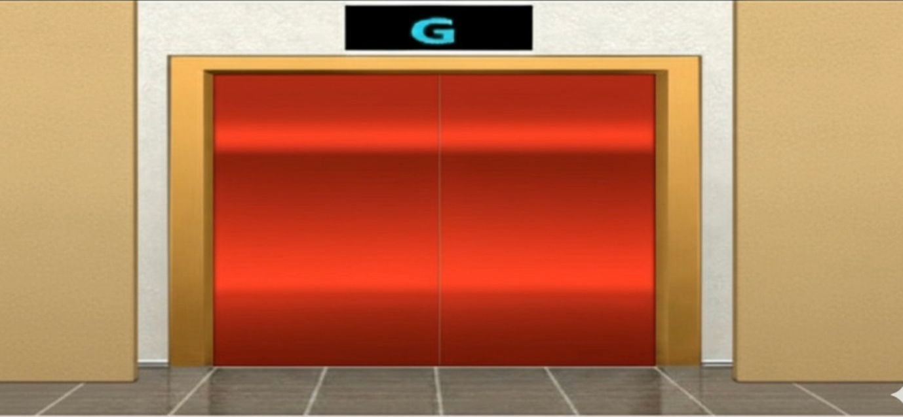

Figure 1: The letter ‘G’ is visible on the elevator display screens

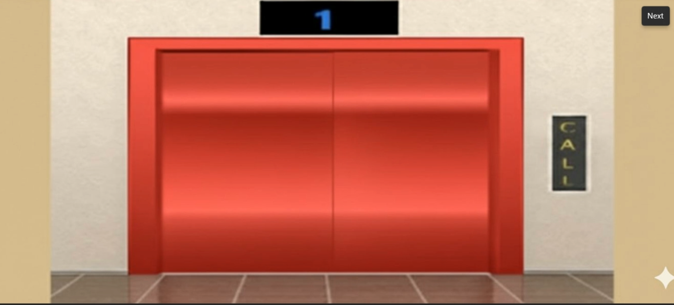

Figure 2: The floor level ‘1’ is visible on the elevator display screens

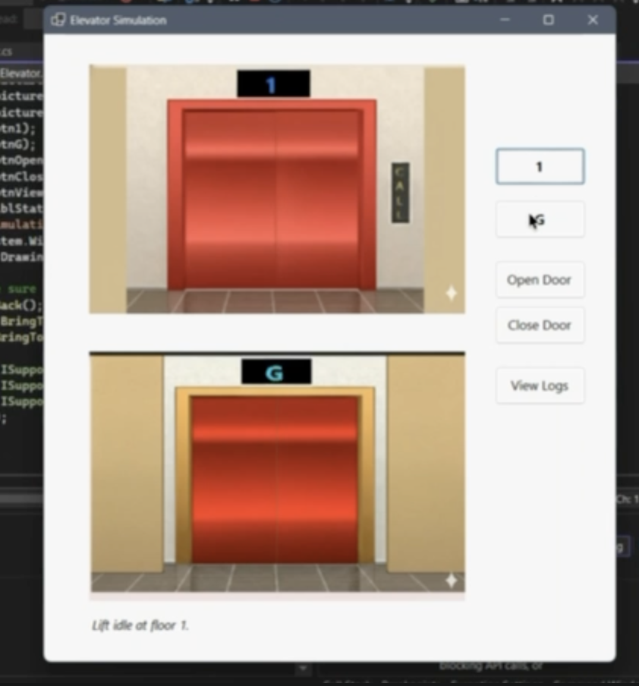
Figure 3: Lift Setup

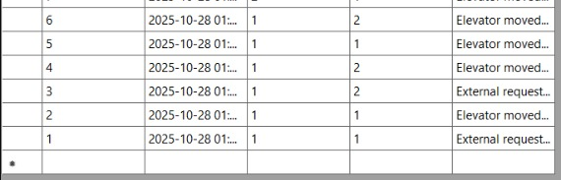

Figure 4: logs
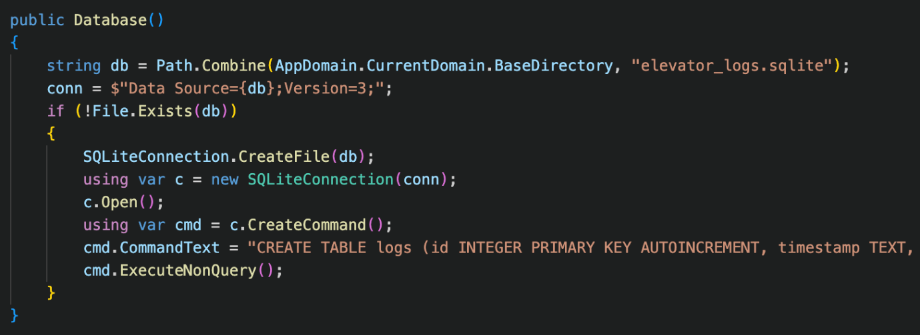

Figure 5: Code snippet 1
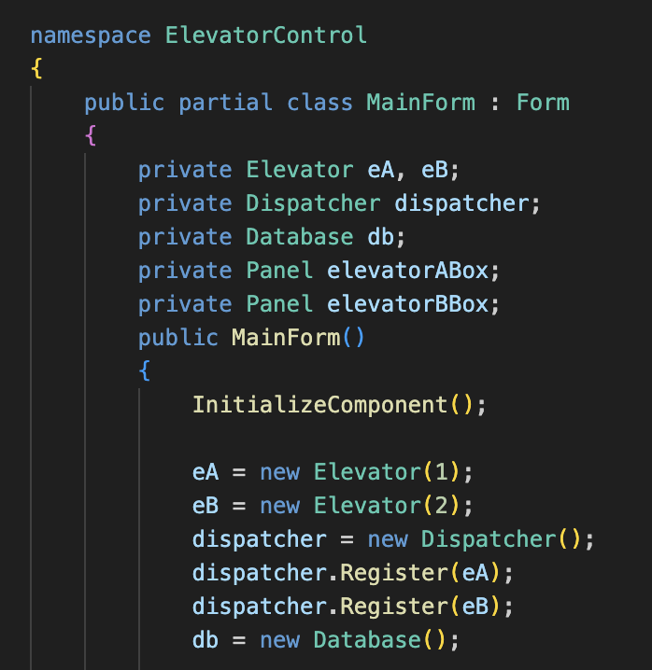

Figure 6: Code snippet 2
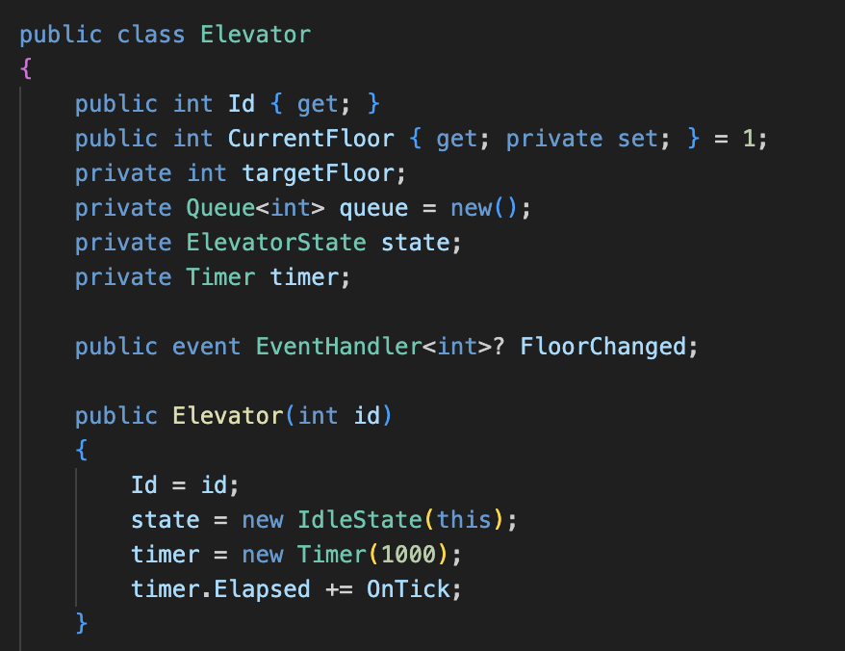

Figure 7: Code snippet 3

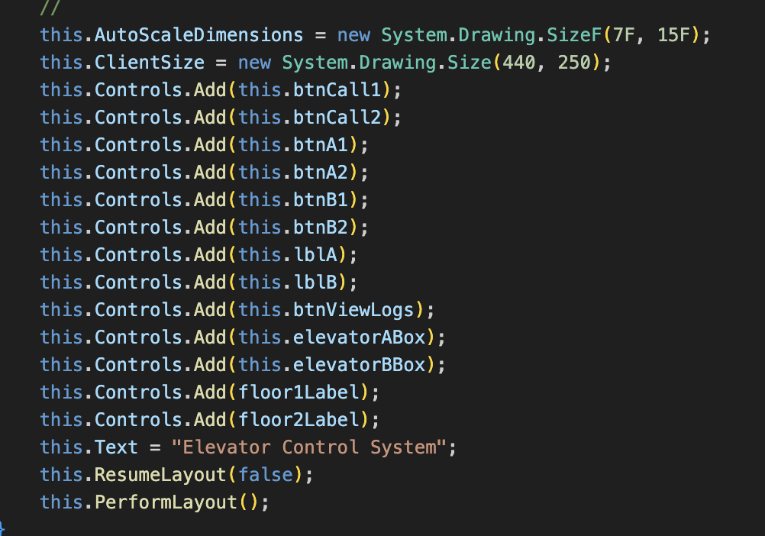
Figure 8: Code snippet 4

6. Handling Errors & Exception Tests
- Database access failure-Manually locked .db file, the program has caught the exception gracefully and displayed no crash.
- Last Covers - store the last cover of the event subscriber.
- UI misclick spam: Tested the rapid clicking of all the buttons -- no freezes or race condition observed.
- Data integrity: One of the checks can be for no duplicate timestamps or for corrupted records.
- Start-up recovery: Application recreated database and resumed also are automatically.

Overall reliability showed high with no cases of crash in extended operation.

7. Performance Testing and Portability Testing
The compiled application was run on four different laptops in windows 10 and 11. Startup time was 1.1 seconds on average and the memory footprint was lower than 40MB. Nothing other than the SQLite DLL included was required. The relative-path concept proved my guess to be true: when the folder was copied to a different machine the functionality was maintained.
CPU utilization was even less than 3% even with concurrent operation. Timers function with fixed 300 ms, which was supported by under 300 ms jitter times in the Windows message loop throttling code.

8. User Experience Evaluation
Feedback from peer testers that indicated that the interface is intuitive and responsive. Button labels are self-explanatory and logs in real time are a nice way to see transparency of activity in the system. The visual difference between the two elevators helped users to easily understand the functionality of the elevator that handles each user request. Minor suggestions for improvement were added, e.g. color indicators or icons to further represent the movement of the elevator, all regarded as optional for this academic version.
The limitations include:
Bourne also stated Generally, positive displacement pumps are usually exhibiting quite high efficiency and can maintain the flow during start-stop periods in a transmission service pipeline. Limitations and Improvements To be made in the future Many advantages of positive displacement pumps in positive displacement pumps: generally, positive displacement pumps have a relatively high efficiency and have no problem maintaining flow in start-stop periods of a transmission service pipeline.
- Simplified State Pattern: They have implemented using an enum for the states instead of different state classes. While functionally adequate, a future version could exchange the information to a full hierarchy of State classes for clarity's sake.
- Static Floor Count: Currently limited to two floors, but it seems that the application could easily be scaled to work with multiple floors with added UI controls and scheduling logic.
- No graphically representing elevator shaft: Movement is depicted as textual updates: future improvement could be to have animated panels or PictureBoxes for better representation
- Single-threaded timer for a more realistic approach (i.e. asynchronous with cancellation tokens), timer could serve as a means of dealing with each elevator individually.

9. Conclusion
Comprehensive testing shows the satisfaction to all assignment requirements and reliable performance of the Elevator Control System in several environments. All the functionalities, including GUI responsiveness, elevator scheduling, database logging, and other background concurrency, are working properly without runtime errors. The system is portable, stable and maintainable.
The testing phase gave not only a claim of correctness of each feature, but was aimed at the robustness of whole architecture. With good modular separation (Elevator, ElevatorController, Database and MainForm) the program has good object-oriented design principles. Future improvements might add to the scalability and visual realness, however, currently the implementation is a solid baseline implementation which is completely functional and conforms to the anticipated academic standard.

